**EXP NO: 19 Compare IT software NAME : ADHIYAN PERIYAR R P**

**DATE: 25/09/2025 ROLL NO : 231901002**

**Aim :**

**Comparison of two Files for forensics investigation by Compare IT software**

**Procedure :**

* Compare It is a software that displays 2 files side by side, with colored differences sections to simplify analyzing. You can move changes between files with a single mouse click or keystroke, and of course, you have the ability to edit files directly in comparison window. It can make colored printout of differences report, exactly as it’s

on the screen.

* Install the Compare It Software.

* Click on Compare It Tool, It will show a window to select the files to be compared.

* First, select the first file and click on open and then select the second file and click on

open.

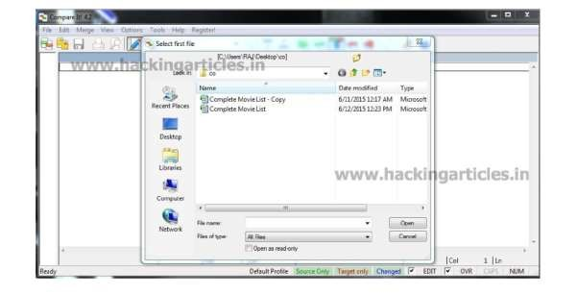

Now it will show us the changes in the highlighted bar.

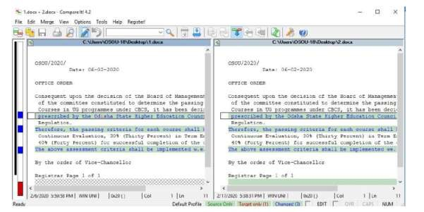

It also gives you Print report of the difference in the file as follows

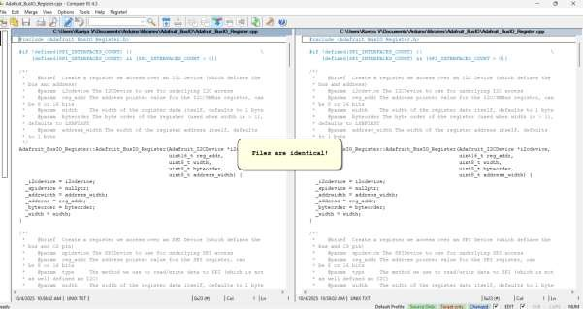

**Result:**

Thus, the forensic tools executed successfully, and the evidence was captured and analyzed accurately.